Git Lab to Rally Test Automation Results Integration

Contents

1. ConnectALL Configuration 2

2. Rally configuration 14

3. Robot Framework script configuration 15

4. Git lab setup 17

|  |  |  |  |
| --- | --- | --- | --- |
| Author(s) | Version | Published Date | Modified |
| Venkateshwarlu Bhupathi | 1.0 | 11/14/2023 | Initial version |

# ConnectALL Configuration

Step1: Get the credentials form Rally team to login to ConnectALL.

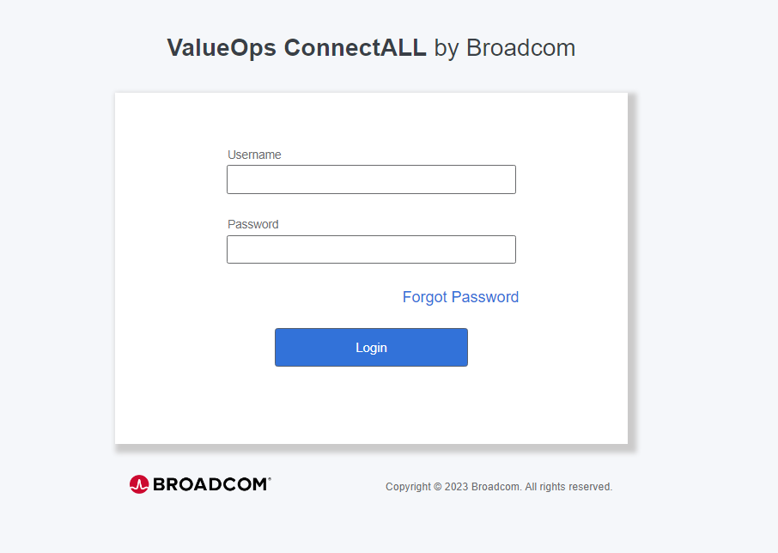

Step2: Login to connect all and generate API Key

Click on profile icon and select “User Management.”

Select API Key & generate API Key

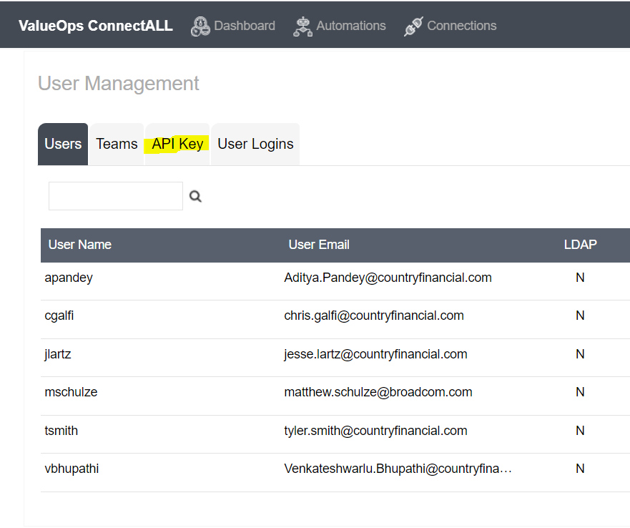

Step3: Click on Connections

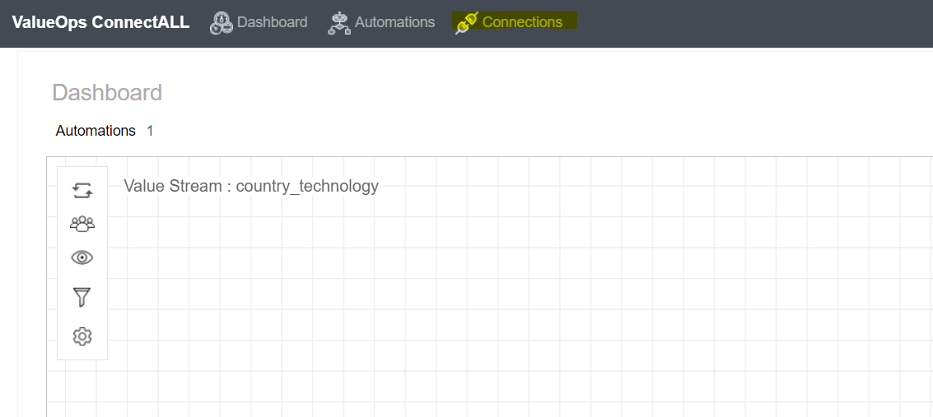

Click on Add connection.

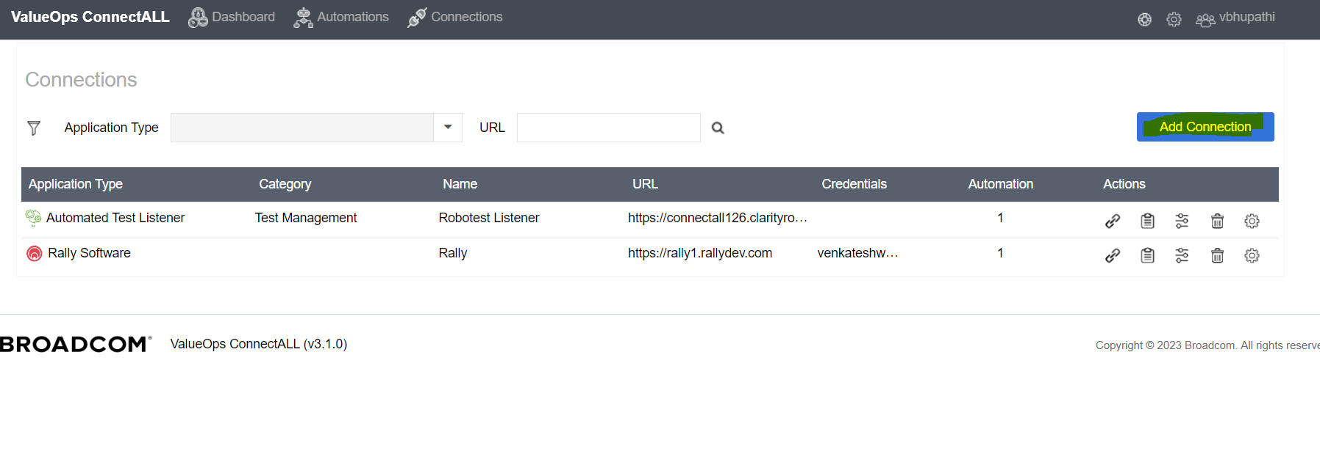

Select “Automated test Listener.”

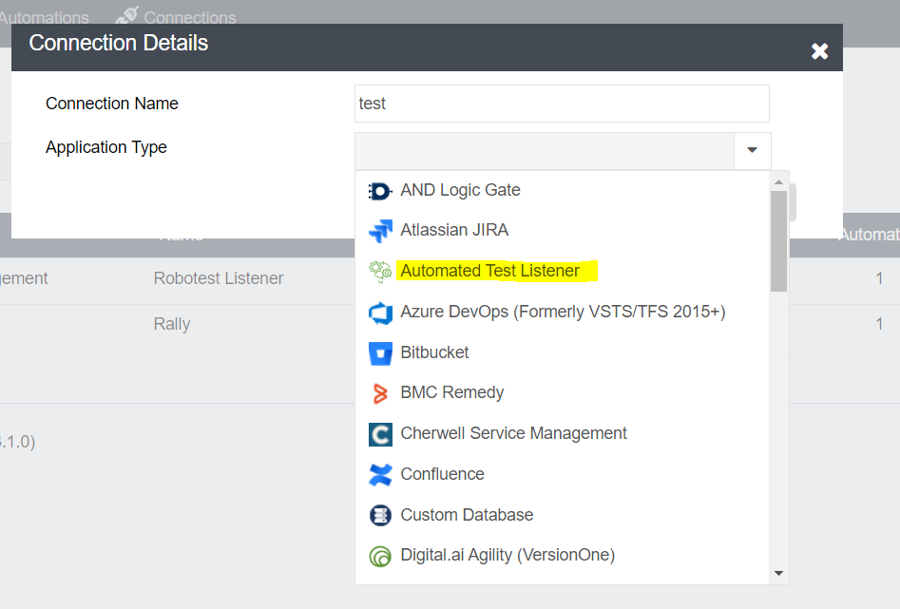

Provide the details.

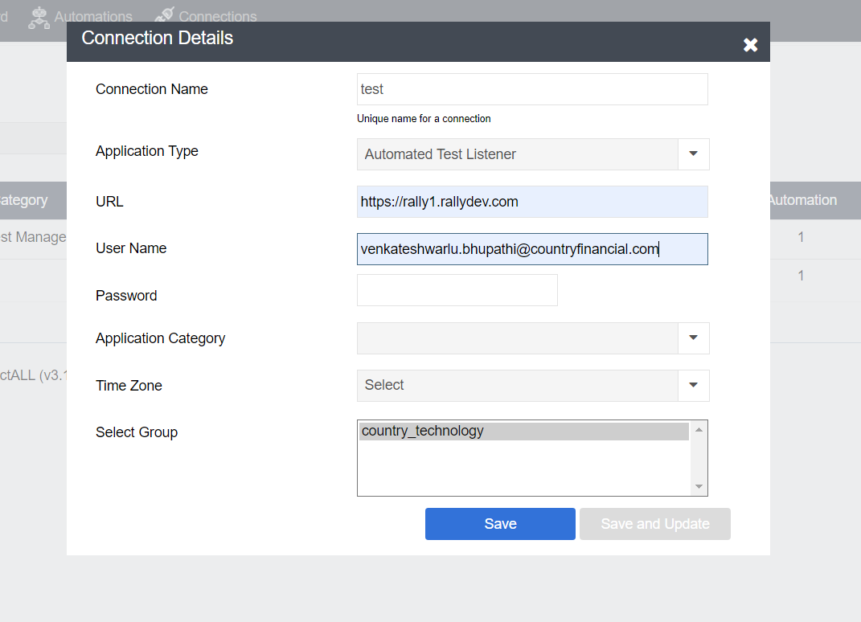

Click on Save

Step4: Click on Add connection.

Select “Rally software”

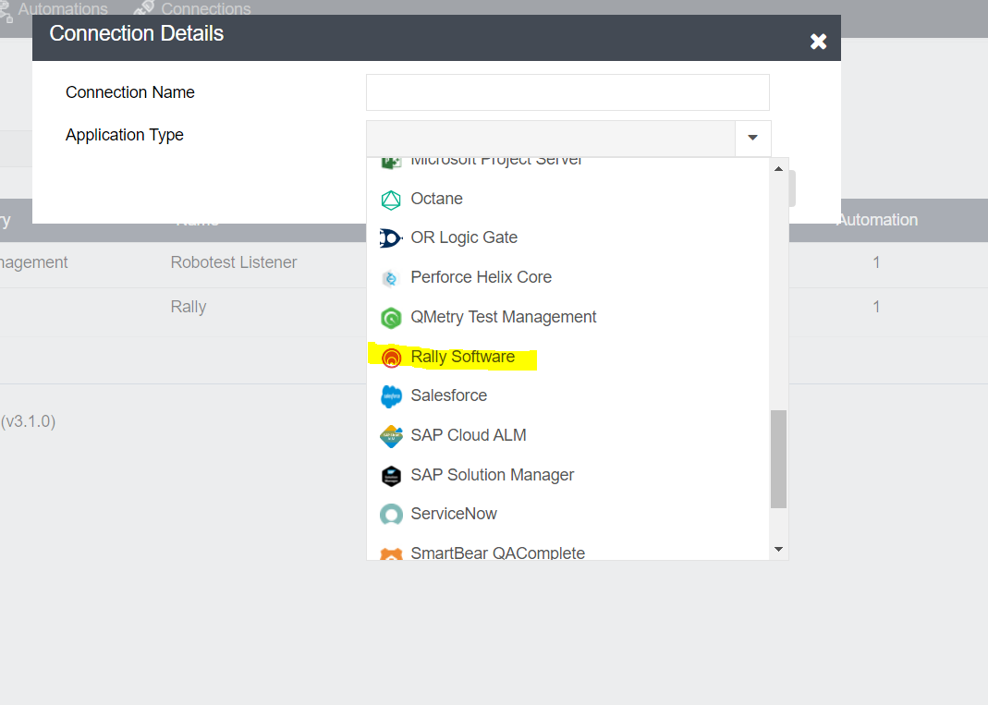

Update the details and save.

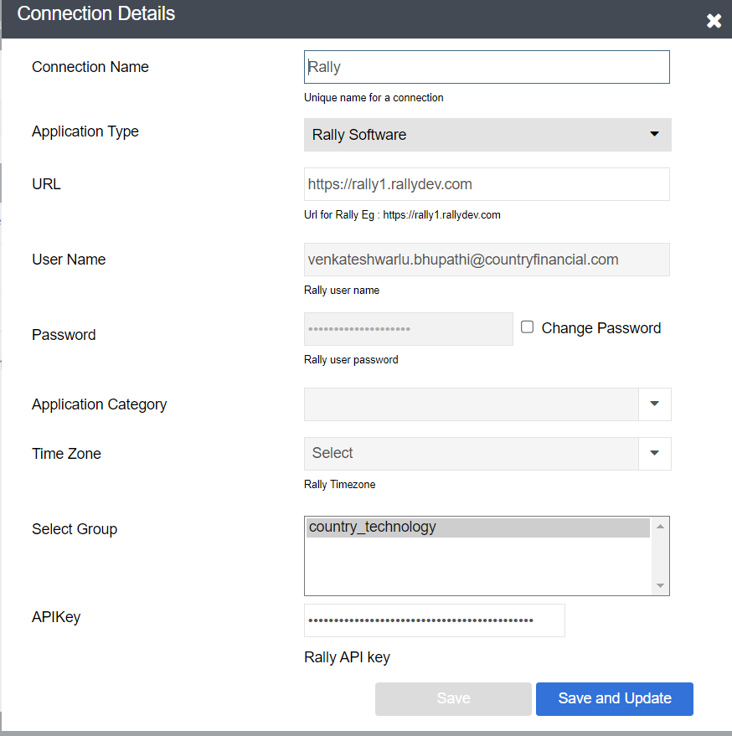

Step5: Click on Automation

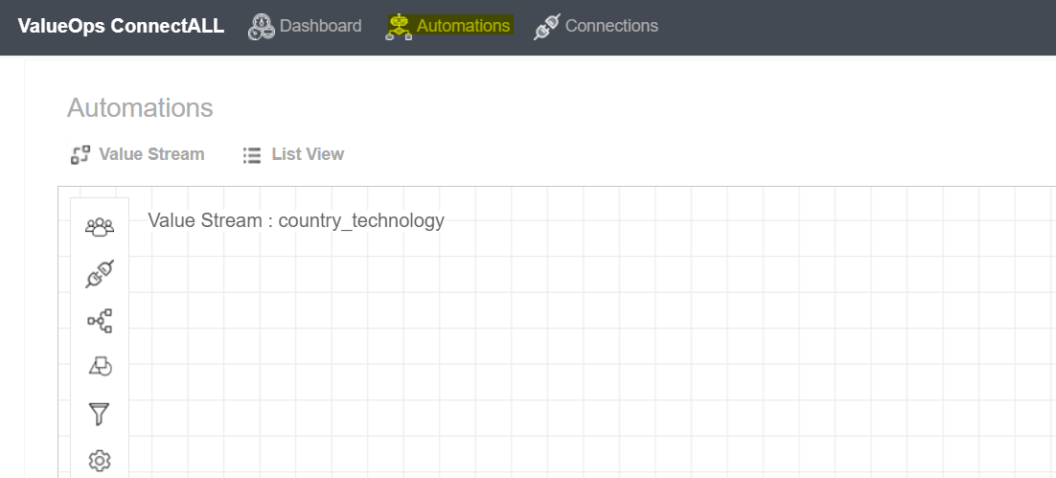

Select Applications icon.

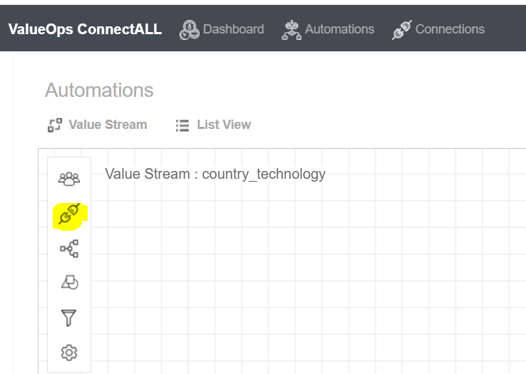

Select “Test Listener and Rally software Icons from the list and drag and drop”.

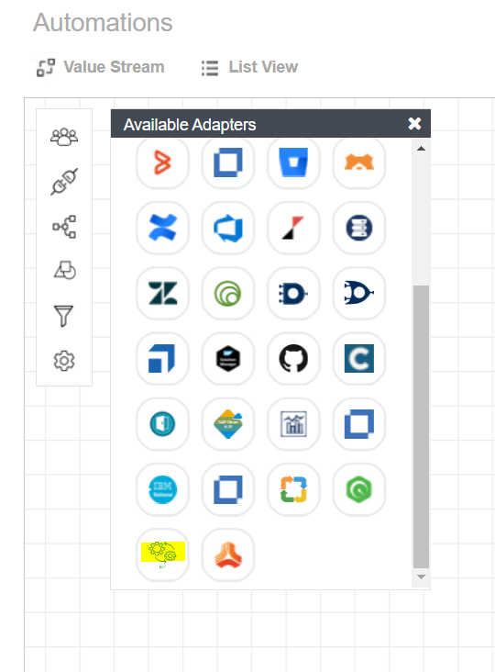

Connect these two icons and name it to “TestResults.”

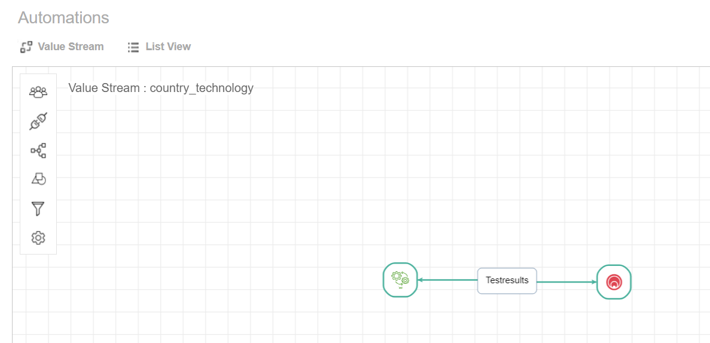

Click on Testresults --🡪 click on hamburger symbol.

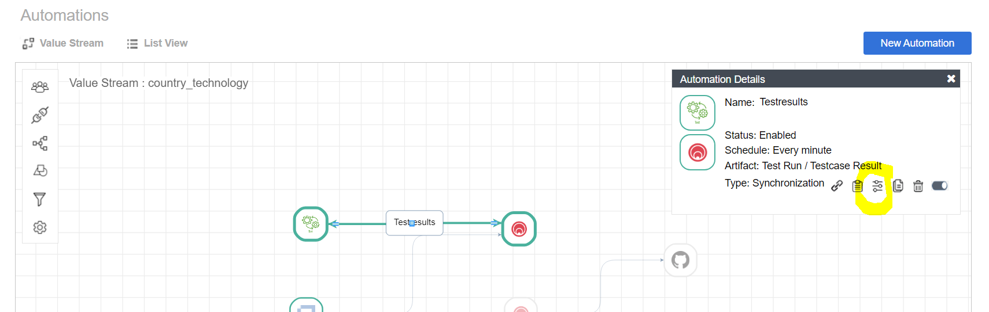

Select Entity Mapping

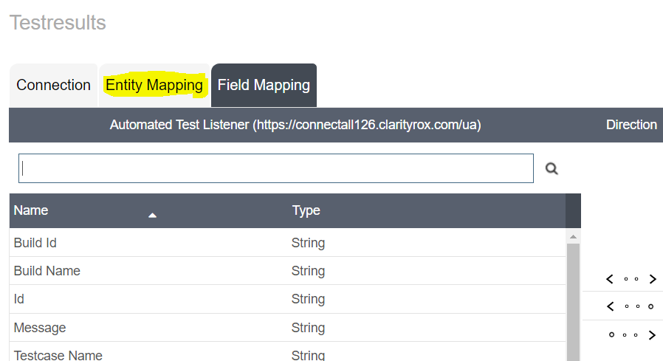

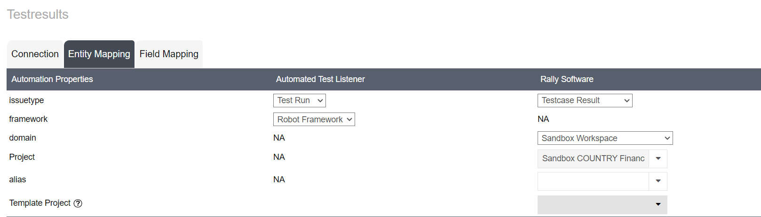

Test Listener:

Issue Type- Test Run

Framework- Robot Framework

Rally :

Issue Type- Testcase Result

Domain- Sandbox Workspace (Select workspace and project where it should update the results)

**Select sync type - Push.**

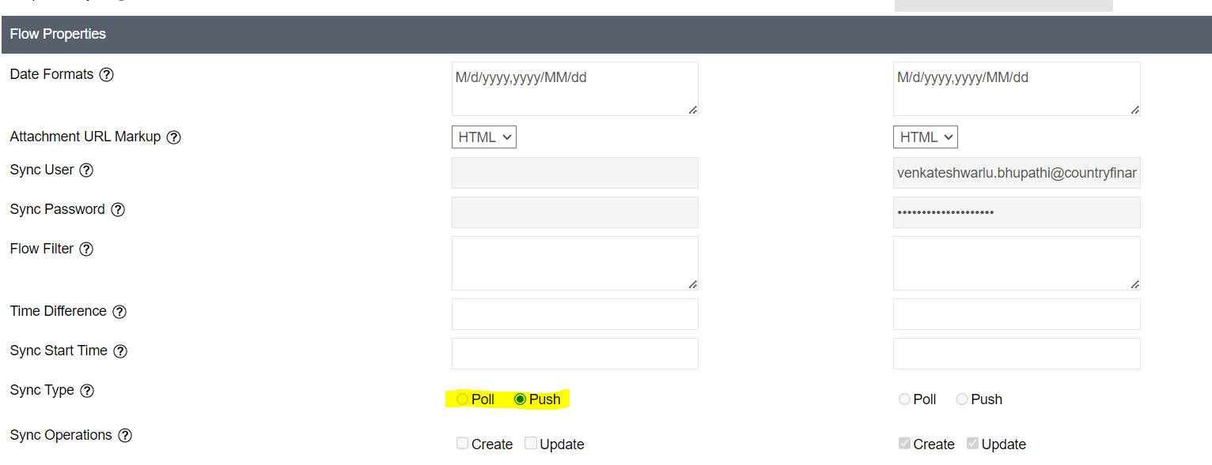

**Select Field mapping.**

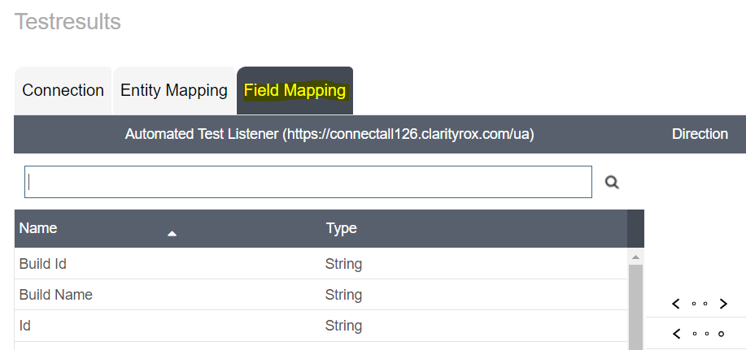

Mapp the fields (Automated Test Listener to Rally) like below screenshot

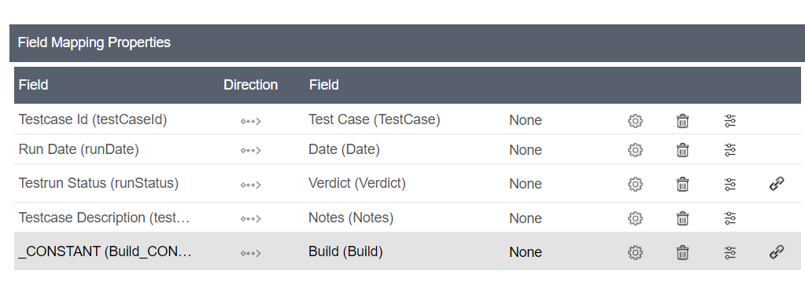

Select Testrun Status (edit)

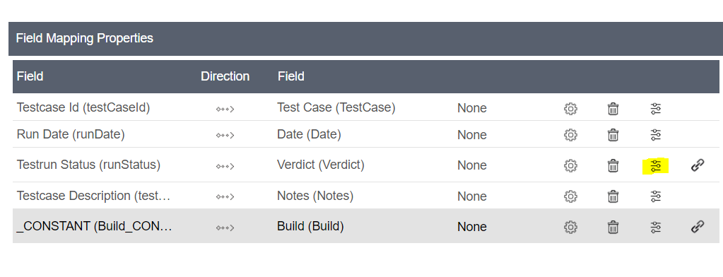

Map fields.

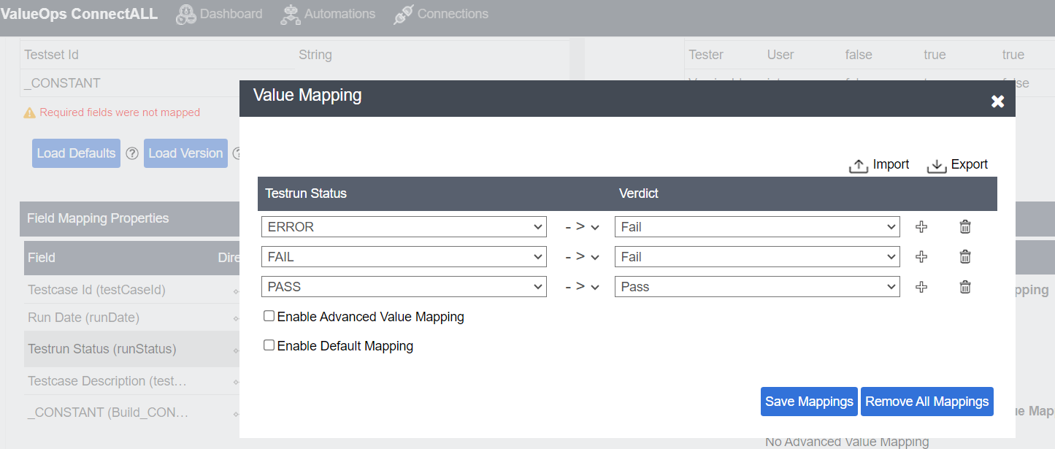

Click on Save mappings.

Click on Save

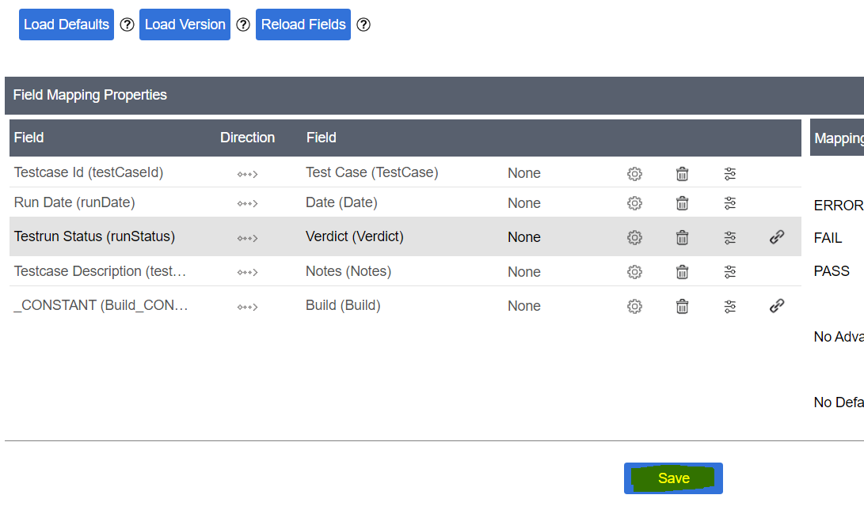

Enter version description and Save Mapping

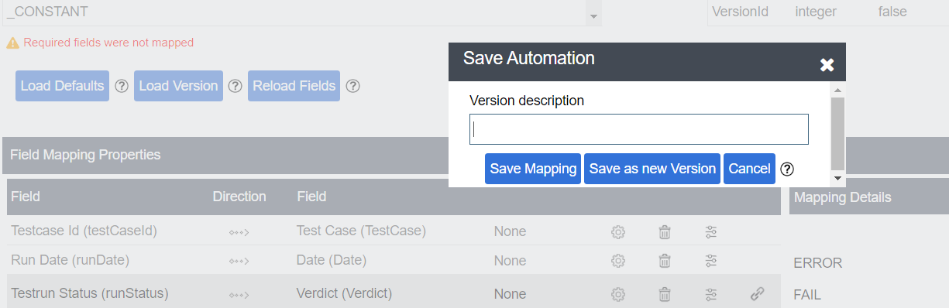

# Rally configuration.

Login to Rally and create test cases

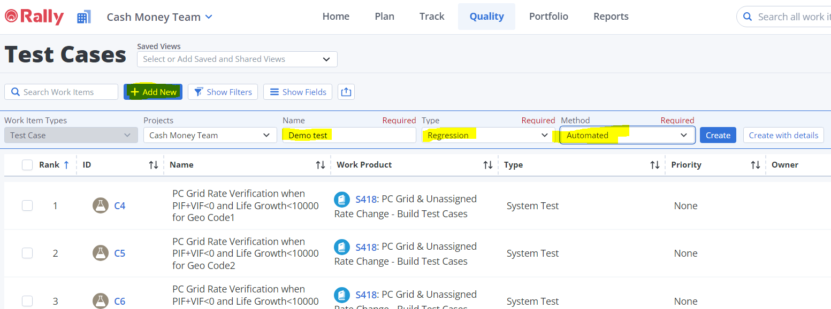

Open the test case and get the test case ID from URL (Highlighted )

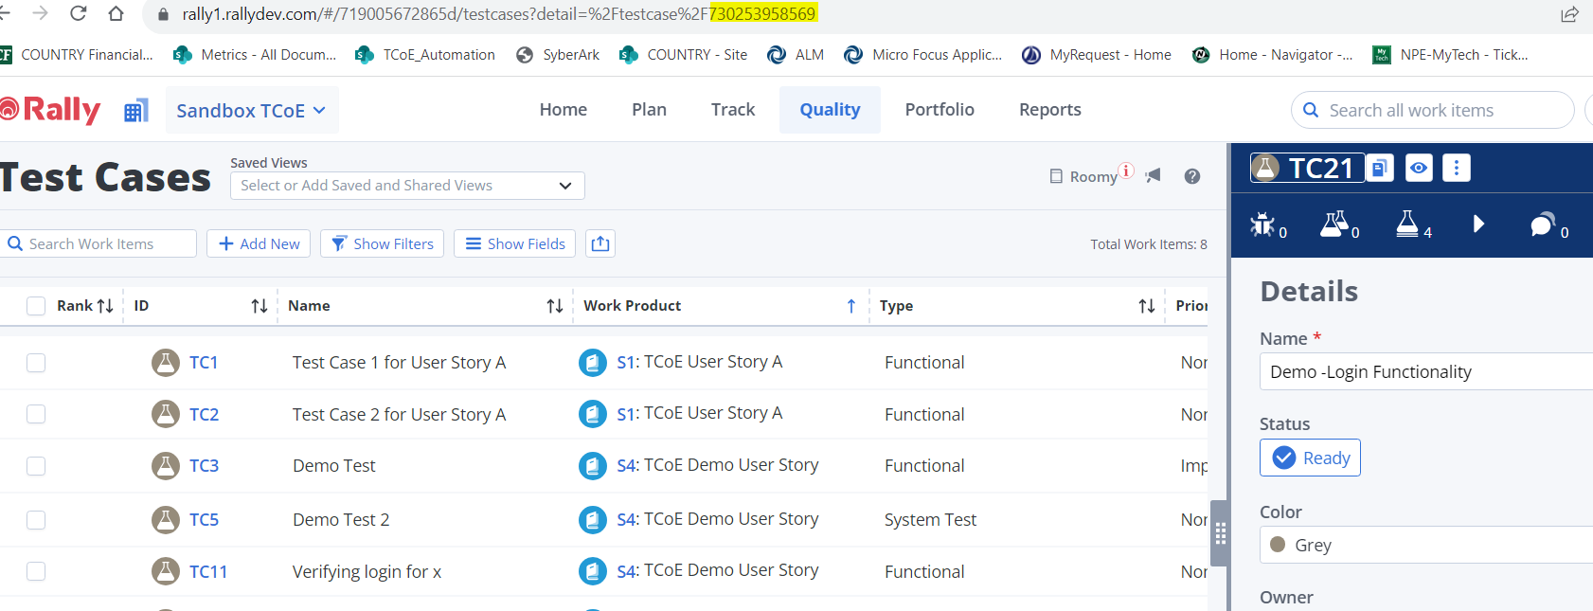

# Robot Framework script configuration

1. Open Robot script and add Tags

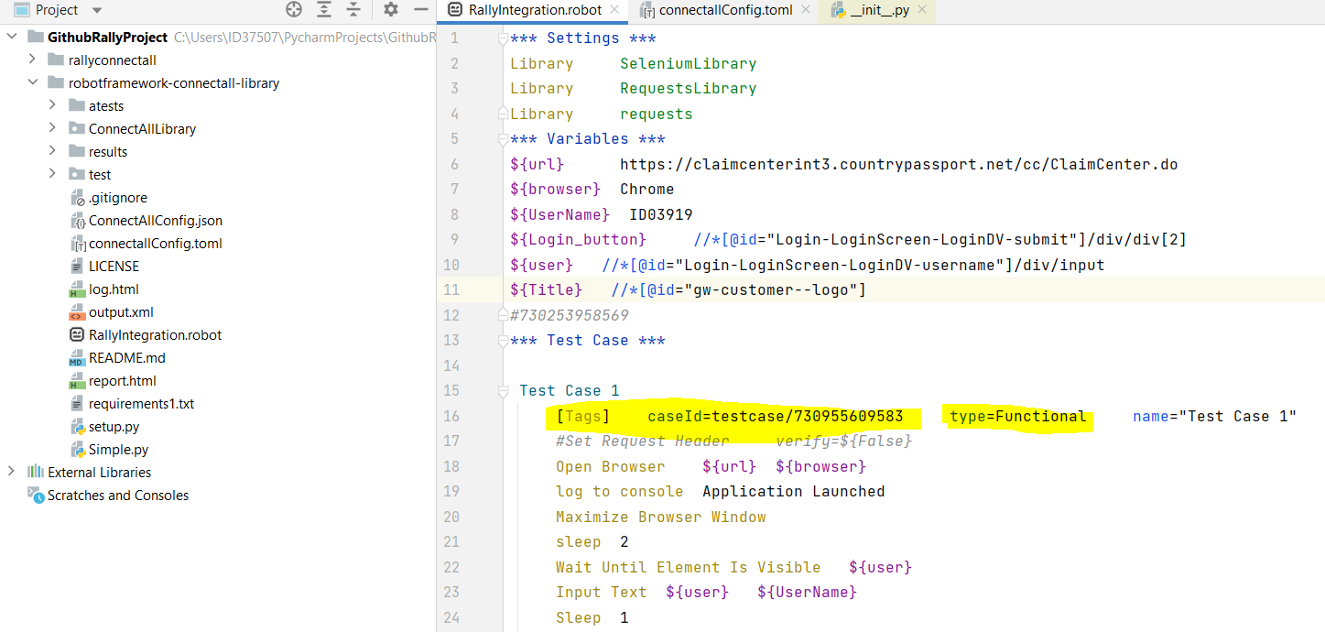

Test case ID (from Rally), type (Functional/Regression --- from rally), Name, Description.

This Test case ID will link to the Rally test case.

1. Create .toml file for configure ConnectALL.

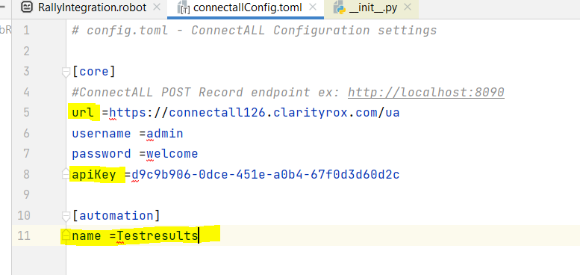

URL: Connect all URL.

Api Key: from Connect all.

Name: from Connect all.

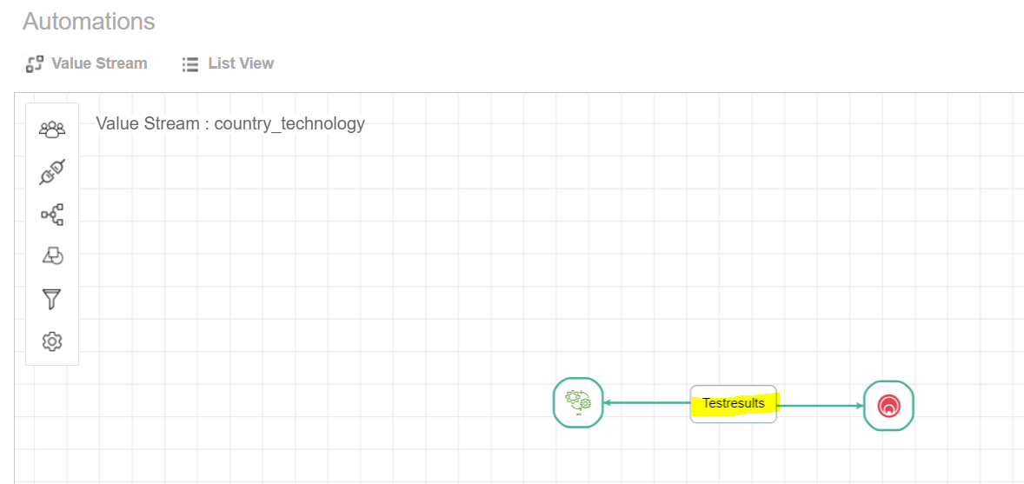

# Git lab setup

Push all scripts in to Git Lab

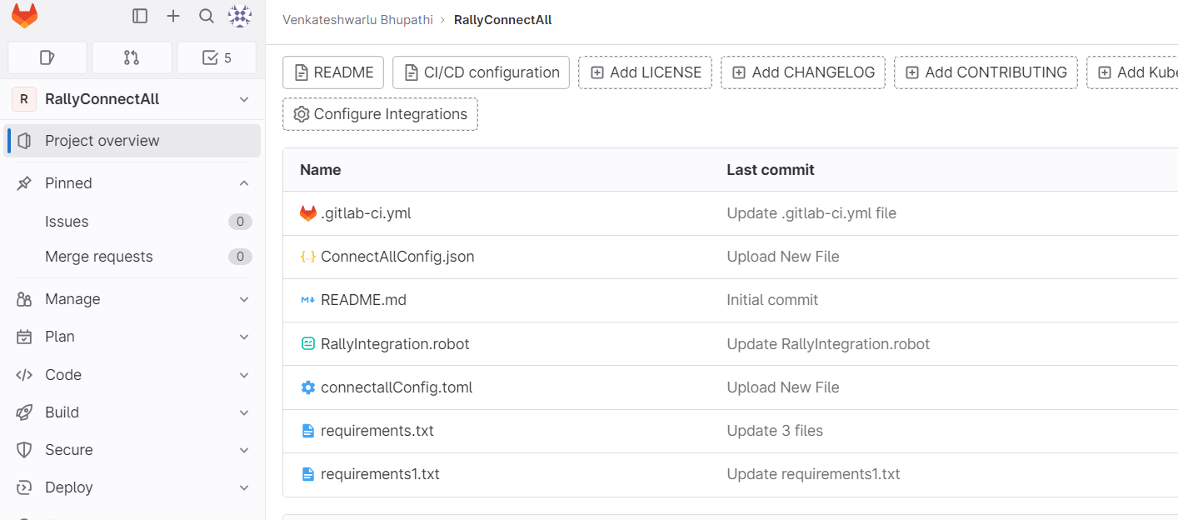

Open .yml file 🡪 update with below commands

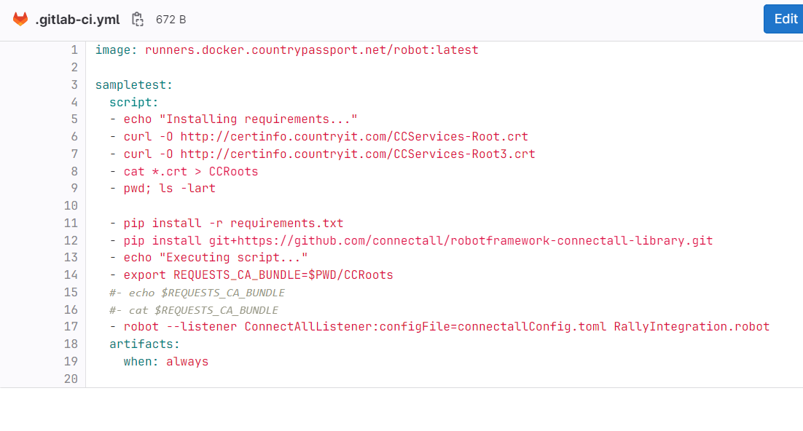

Execution flow:

1. Install required software.
2. Download and execute SSL certificate.
3. Install Listener (from config.toml ) -🡪 this will establish connection between Git lab and Connect all `
4. Execute the Robot script.
5. Go to pipeline schedule and run.

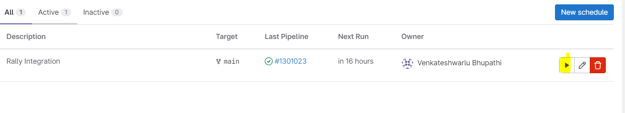

1. Verify status in Jobs.

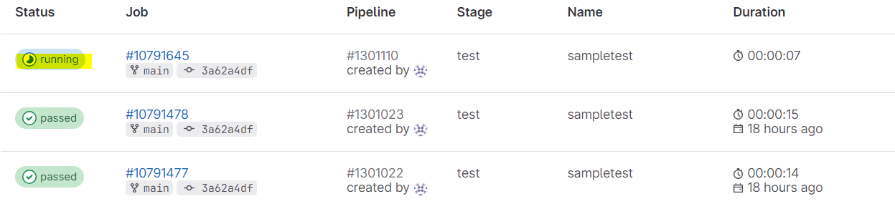

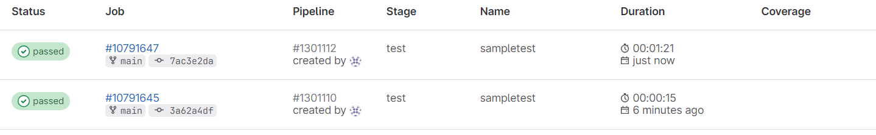

1. Verify results in Rally test case status.

